Lesson 11
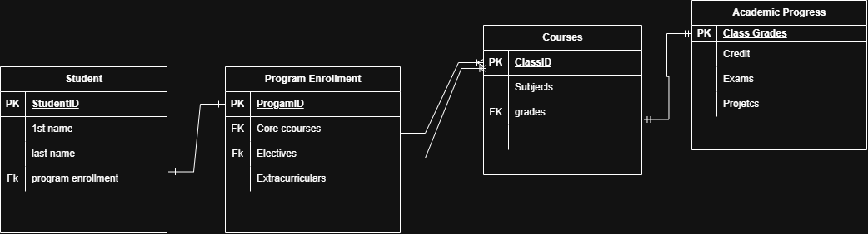

4 Entities: Student, Program Enrollment, Courses, Academic Progress

Attributes
Student Entity: 3 attributes, 1st name, last name, program enrollment
Program Enrollment Entity: 3 attributes, core courses, electives, extracurriculars
Courses Entity: 2 attributes, subjects, grades
Academic Progress Entity: 3 attributes, Credit, Exams, Projects

Relationships:
Program enrollment – one to one- Program ID
Core courses- one to many- Class ID
Electives – one to many- Class ID
Grades- one to one- class grades

